BAHRIA UNIVERSITY (KARACHI CAMPUS)
Computing Fundamentals (CSC - 110)
Assignment 02
Fall 2022

Class: BSE 1B Shift: Morning
Course Instructor: ENGR. MAHAWISH Submission: 2 Dec 2022
Date: 26 Nov 2022 Marks: 05 Points
Student Name: ABDULLAH Registration #: 02131222099



[CLO-3]

Question no. 01 [5 Marks]
Perform the following logical operations justify through truth tables and draw circuit diagrams.
- (A AND B)
- NOT (A XOR B)
- NOT(A) OR NOT(B)
- C XOR (A OR B)
- {(A NAND B) XNOR (C AND D)}
Solution:
- (A AND B):

Truth Table:

Input A | Input B | Output A AND B
0 | 0 | 0
1 | 0 | 0
0 | 1 | 0
1 | 1 | 1
Circuit Diagram:
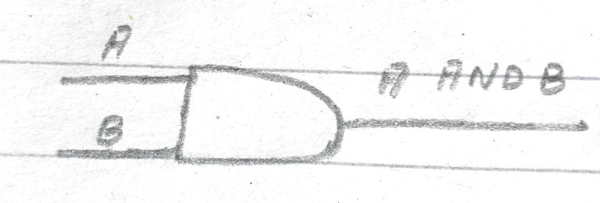
- NOT (A XOR B):

For A XOR B

Truth Table:

Input A | Input B | Output A XOR B
0 | 0 | 0
1 | 0 | 1
0 | 1 | 1
1 | 1 | 0

Circuit Diagram:
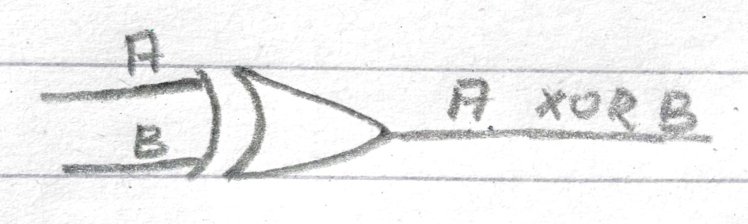

Now For NOT (A XOR B)

Truth Table:

Input (A XOR B) | Output NOT (A XOR B)
0 | 1
1 | 0
1 | 0
0 | 1

Circuit Diagram:
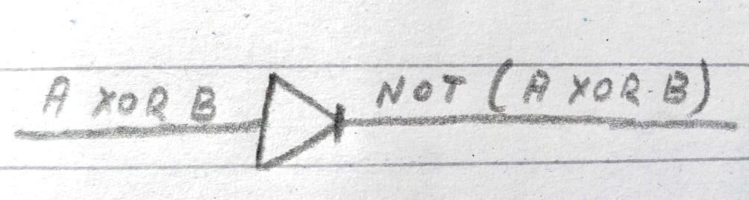
- NOT(A) OR NOT(B):

For NOT (A)

Truth Table:

Input (A) | Output NOT (A)
0 | 1
1 | 0

Circuit Diagram:
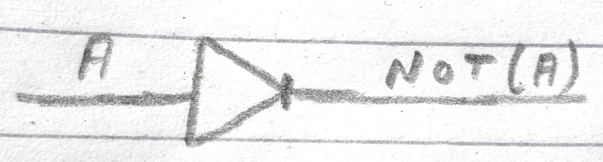
For NOT (B)

Truth Table:

Input (B) | Output NOT (B)
0 | 1
1 | 0

Circuit Diagram:
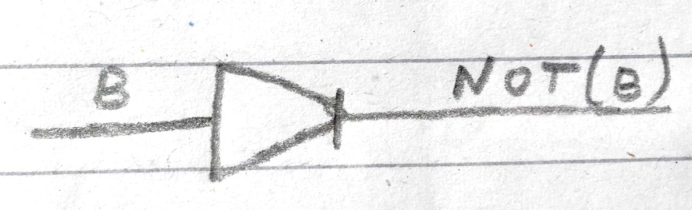
For NOT (A) OR NOT (B)

Truth Table:

Input NOT (A) | Input NOT (B) | Output NOT (A) OR NOT (B)
1 | 1 | 1
0 | 0 | 0
Circuit Diagram:
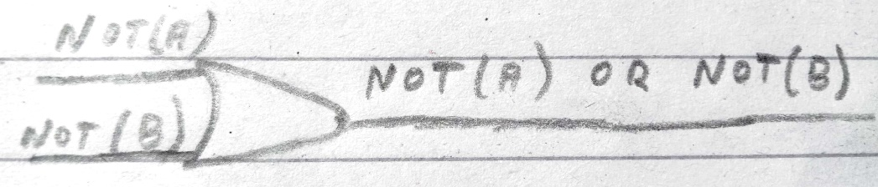

- C XOR (A OR B):

For (A OR B)

Truth Table:

Input A | Input B | Output A OR B
0 | 0 | 0
1 | 0 | 1
0 | 1 | 1
1 | 1 | 1

Circuit Diagram:

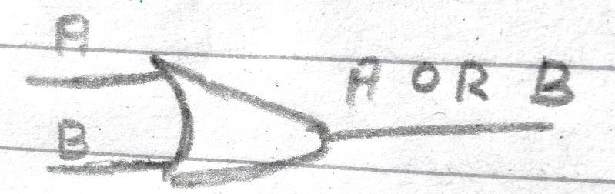

For C XOR (A OR B)

Truth Table:

Input (A OR B) | Input C | Output C XOR (A OR B)
0 | 0 | 0
1 | 1 | 0
1 | 0 | 1

Circuit Diagram:

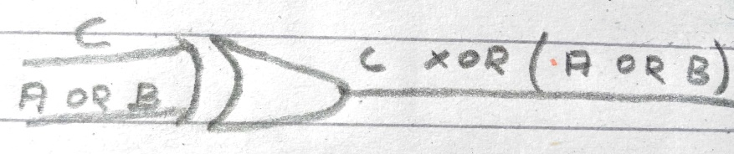

- {(A NAND B) XNOR (C AND D)}:

For (A NAND B)

Truth Table:

Input A | Input B | Output A NAND B
0 | 0 | 1
1 | 0 | 1
0 | 1 | 1
1 | 1 | 0

Circuit Diagram:

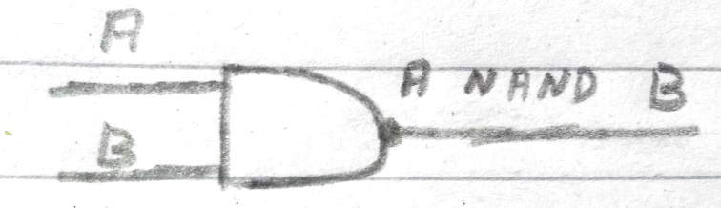

For (C AND D)

Truth Table:

Input C | Input D | Output C AND D
0 | 0 | 0
1 | 0 | 0
0 | 1 | 0
1 | 1 | 1

Circuit Diagram:
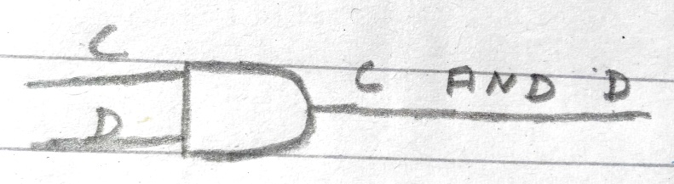

For {(A NAND B) XNOR (C AND D)}

Truth Table:

Input (A NAND B) | Input (C AND D) | Output {(A NAND B) XNOR (C AND D)}
1 | 0 | 0
1 | 0 | 0
1 | 0 | 0
0 | 1 | 0

Circuit Diagram:

